Employee Training Guideline

All company employees must complete the ESET Cyber Security Awareness program within their first six months of being hired. Holding this standard as a policy will help ensure that the employees take security measures seriously as it becomes part of the company’s environment. The CISO must also take security just as seriously and make sure from top-down that everyone working with the business is on the same page with security.

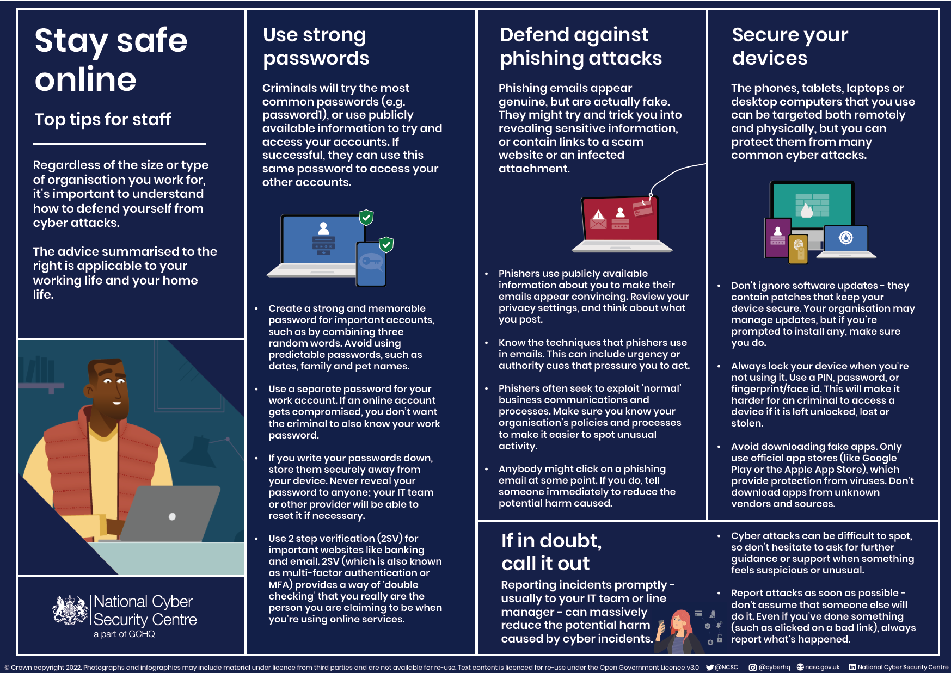

For employees to begin on their training for Cyber Security Awareness, you must go here: <https://www.eset.com/us/business/cybertraining/> and enroll in the free training at ESET.